Summary Notes — Liabilities
Topic: Liabilities — Operating, Contingent, and Financial

Introduction
Companies need capital, and it comes from two sources: owners (shareholders) and non-owners (lenders, suppliers, customers). Owner capital is permanent — there's no obligation to repay it. Non-owner capital is temporary — it must be satisfied by paying cash or delivering a product or service on time. The ratio between the two is the capital structure.
Non-owner capital generally demands a lower return than owner capital, so it's cheaper. But it introduces risk: obligations come due at maturity, and financial liabilities carry a contractual cost. So companies seek the optimal mix of the two.
A liability is a company's legal financial debt or operating obligation arising in the course of business. To be recognized it must be probable, the result of a past transaction, and reasonably estimable in amount. Liabilities are reported by maturity — current (settled within a year) or long-term (beyond a year) — and by source — operating (e.g., accounts payable, deferred revenue) or financial (loans and bonds). Because accounting is conservative, companies also disclose other potential liabilities, with the disclosure depending on how likely they are to materialize.

Operating Liabilities
Operating liabilities arise from operating activities:
- Accounts payable (AP): amounts owed to vendors for goods and services received but not yet paid — the value of outstanding, unpaid invoices.
- Accrued expenses: costs incurred but not yet paid. Salaries earned before payday are recorded as accrued compensation; the same logic covers rent, professional fees, and taxes incurred but unpaid.
- Deferred revenue: cash invoiced (often collected) before the product or service is delivered. The revenue isn't earned yet, so a liability sits on the balance sheet until delivery.

Contingent Liabilities
A contingent liability is a potential obligation from a past event that becomes definite only if some future event occurs. How it's treated depends on probability and estimability:
- Probable and estimable: recorded immediately — an expense on the income statement and a liability on the balance sheet (e.g., a fine under appeal).
- Possible, or not reasonably estimable: disclosed in the footnotes, but nothing is recorded (e.g., an ongoing lawsuit of uncertain amount).
- Remote: no recording and no disclosure required.
Because management judges both the probability and the amount, contingent liabilities are another opening for earnings management. Two recent cases show the "record it" threshold in action. 3M's settlement over PFAS ("forever chemicals") in public water supplies — up to $12.5B — led it to book a $10.3B accrual (the pre-tax present value of payments over 13 years): once a loss was probable and estimable, it became a liability and an expense. Johnson & Johnson has built an approximately $11B reserve for talc litigation, adding a $2.7B charge in early 2024 as its estimate rose. Contrast these with a fresh lawsuit of uncertain outcome, which stays in the footnotes until it becomes estimable — a good illustration of how the same matter moves from disclosure to the balance sheet as the facts firm up.

Financial Liabilities
Financial liabilities (debt) reflect capital from financial partners (banks, investment firms). Companies pay interest for it, recorded as interest expense on the income statement.
Debt can be short-term (repaid within a year) or long-term (beyond a year), and either type can be a bank loan, private funding, or a public security (commercial paper or bonds). Short-term debt tends to be cheaper and more flexible on amount and timing, but exposes the firm to interest-rate risk (market-rate volatility) and refinancing risk. Firms generally try to match the maturity of debt to the maturity of the assets it finances, though availability, market conditions, and relationships can override that. On the balance sheet, short-term debt and the current portion of long-term debt (due within a year) are current liabilities; the rest of long-term debt is non-current.

Debt details live in the footnotes
- The repayment schedule of each long-term position — debt due in 3 years is very different from debt due in 30.
- The interest rate on each position, and whether it's fixed or floating.
- The currency of the debt — multinationals borrow in several currencies.
- The covenants attached to each position.
- Any assets pledged as collateral.
A good exercise is to pull a real company's debt footnote and find its maturity schedule, its fixed-versus-floating split, its covenants, and any collateral — the details that don't fit on the balance sheet itself but shape the company's risk.

Accounting for financial liabilities
- At borrowing: cash increases and the liability increases by the same amount — no income-statement effect.
- Each period: the interest owed for the period is expensed even if not paid in cash; unpaid interest sits as interest payable. When paid, cash and the payable fall together, with no income-statement effect.
- At maturity: cash and the liability both fall by the amount repaid, and any remaining interest payable is settled — no income-statement effect from the repayment itself.
A quick worked example makes the point. Borrow $1M at 6% for one year: at borrowing, cash rises $1M and debt rises $1M, with no income effect. Over the year, $60,000 of interest expense accrues on the income statement (paid in cash, or booked as interest payable until paid). At maturity, repaying the $1M principal reduces cash by $1M and debt by $1M — again no income effect. Only the $60,000 of interest ever touches the income statement; borrowing and repaying principal do not.

What Determines the Interest Rate
The rate on a company's debt reflects factors partly outside its control (markets) and partly within it (strategy, performance, industry):
- Nominal base rate: the risk-free rate including inflation, set by markets and central-bank policy. It anchors the whole cost of debt and shapes companies' ability to invest and grow.
- Maturity premium: longer maturities carry more risk for the lender, so they command a higher rate.
- Default premium: riskier borrowers pay more; the risk is captured by the credit rating, which reflects the probability the company pays in full and on time. Ratings come from S&P, Moody's, and Fitch — the three dominant agencies. They run from AAA (highest) down to D (default), and the line between "investment grade" and "high-yield" (junk) is BBB−/Baa3; the lower the rating, the wider the default premium.
- Other: security liquidity, regulatory risk, and company-specific factors.
The base rate is not a constant. After years near zero, the Fed raised the federal funds target range to about 5.25–5.50% by mid-2023 to fight post-COVID inflation, then began cutting in late 2024; by 2026 the effective rate had eased to roughly 3.5% (see chart). That single macro variable moves every company's cost of debt, reshapes refinancing, and can stall or restart investment. Remember that a company's actual borrowing cost is the base rate PLUS its own credit spread — so a downgrade widens the spread on top of any move in the base rate.
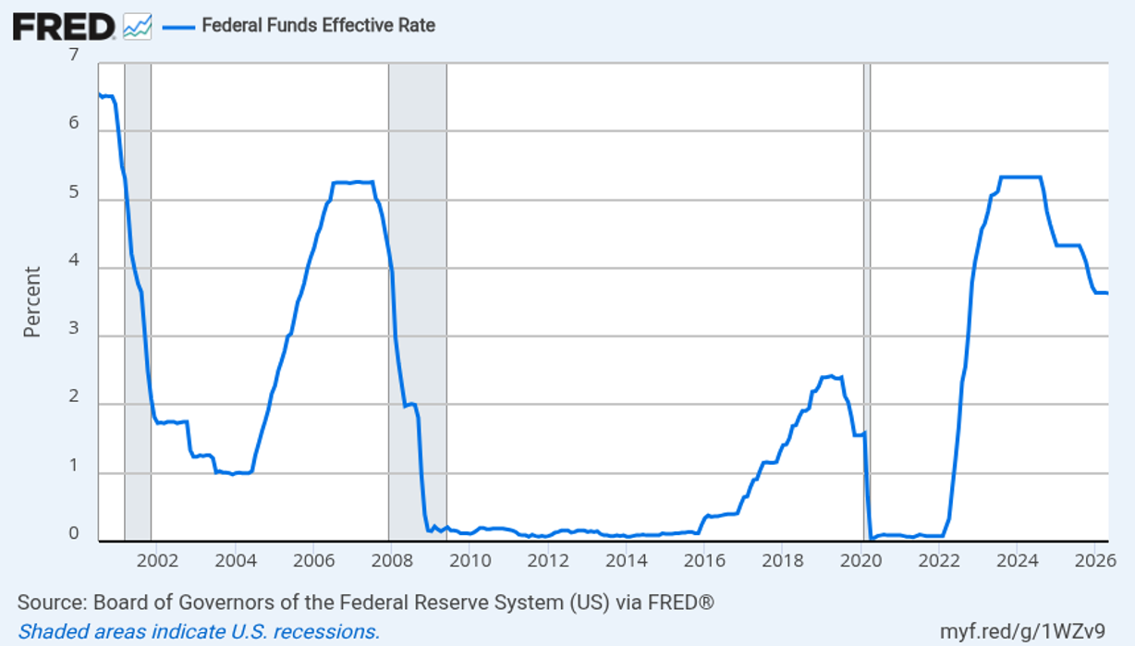
Federal Funds Effective Rate, 2001–2026. Source: Board of Governors of the Federal Reserve System (US) via FRED.

The credit rating depends on
- Business risk: industry characteristics, competitive position, management team.
- Financial risk: leverage and solvency ratios, size, sales growth, profitability.

Assessing the Level of Indebtedness
Non-owner capital is cheaper than owner capital, and the term for the ratio between them is leverage — the more non-owner capital, the more levered the firm. Cheaper capital comes with risk: it must be repaid, and interest is a contractual obligation whose breach can trigger bankruptcy. Bankruptcy is costly — direct (legal and other fees) and indirect (lost business and lost confidence among suppliers, employees, and partners). Sometimes it's a chance to restructure and emerge healthier; often it's the end. So management and partners watch leverage closely.
- Debt/Assets and Debt/Equity: the share of assets financed by debt. There's no ideal level — it varies widely by industry, and asset-heavy firms usually carry more debt because those assets can secure it.
- Interest coverage = EBIT / interest expense: the ability to service debt; higher is safer, and above ~3 is generally considered healthy.
Corporate finance teams seek the optimal level of debt as a trade-off between cost and risk.
Spirit Airlines is a cautionary tale — and one these very ratios would have flagged well in advance. For years Spirit carried heavy debt (around $2.4B of long-term debt) alongside mounting losses and negative free cash flow, so its Debt/Equity was high and its interest coverage was thin to non-existent — signals that it had little cushion to absorb a shock. When weak demand, engine problems, and intense competition hit at once, it could not service its obligations: Spirit filed for Chapter 11 bankruptcy in November 2024, briefly emerged in March 2025, filed again in August 2025, and ultimately went bankrupt and wound down. The lesson is that a deteriorating leverage and interest-coverage profile is an early-warning system — the danger was visible in the ratios long before the failure.

Liquidity Ratios
Liquidity is the ability to pay current obligations. The common measures are the current ratio and the dollar amount of working capital:
- Current ratio = Current Assets / Current Liabilities: above 1 means current assets cover current liabilities. But current assets aren't always liquid (a big inventory may not sell fast), and current liabilities don't always require cash (deferred revenue is settled by delivering a service). Too high a ratio can also signal idle resources.
- Working Capital = Current Assets − Current Liabilities: strongly affects the company's health, profitability, and ability to scale; firms target an optimal level that depends on industry and business model.

